**Project Design Phase**

**Problem – Solution Fit**

|  |  |
| --- | --- |
| Date | 20 June 2025 |
| Team ID | LTVIP2025TMID28652 |
| Project Name | Educational Organisation Using ServiceNow |
| Maximum Marks | 2 Marks |

**Problem – Solution Fit:**

Problem–Solution Fit is the stage in product or project development where a proposed solution effectively addresses a real, well-defined problem faced by a target audience. It means the team clearly understands the user's pain points and has created a solution that directly solves them in a meaningful way. Achieving this fit validates that the problem is worth solving and the solution is viable. It's a critical checkpoint before moving into full development or scaling, as it ensures efforts are aligned with real user needs. Without problem–solution fit, even great ideas risk failing due to lack of relevance or impact.

**Purpose:**

* Solve complex problems in a way that fits the state of your customers.
* Succeed faster and increase your solution adoption by tapping into existing mediums and channels of behavior.
* Sharpen your communication and marketing strategy with the right triggers and messaging.
* Increase touch-points with your company by finding the right problem-behavior fit and building trust by solving frequent annoyances, or urgent or costly problems.
* Understand the existing situation in order to improve it for your target group.

**Template:**

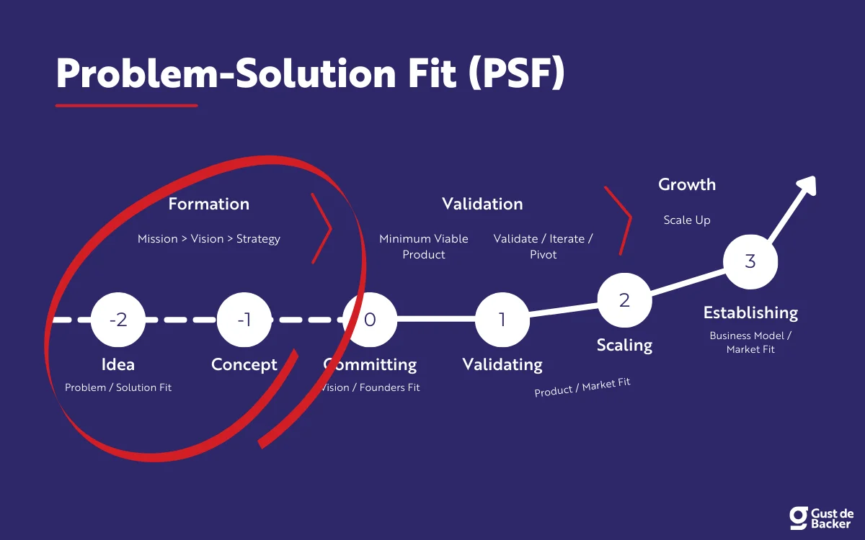

References:

1. <https://www.ideahackers.network/problem-solution-fit-canvas/>
2. <https://medium.com/@epicantus/problem-solution-fit-canvas-aa3dd59cb4fe>